Project title
Eurovision Voting Biases: An Analysis of Jury Discrepancies and Geopolitical Alliances

Team member info:
William Ayoub, 325390557, williamayoub, william.ayoub@mail.huji.ac.il
Ariel Rosenberg, 323103010, ariel.ros1, ariel.rosenberg@mail.huji.ac.il
Bnaya Zaga, 205542970, zaga, Bnaya.Zaga@mail.huji.ac.il
Rephael Blank, 318205895, rephael.blank, rephael.blank@mail.huji.ac.il

Problem description:
We hypothesize that scoring in the Eurovision Song Contest is heavily influenced by factors beyond objective song quality, mainly geopolitical ones. First, we hypothesize there is a measurable discrepancy between the preferences of professional juries and the general public (televoters) which can reflect certain favoritism from the general public reflecting real world events. Second, we hypothesize the existence of entrenched geopolitical and cultural voting blocs, where countries exhibit predictable, directional favoritism towards specific neighbors or allies.

Data:
We obtained the "Eurovision Finals Voting Results (1957-2021)" dataset. It is a CSV file containing approximately 13,500 records (rows) and is approximately 750kb in size. The dataset contains historical voting logs, with key columns including Year, From (giving country), To (receiving country), Points, and Points type (e.g., distinguishing between jury votes and televotes). The data was sourced from Kaggle (link here).

Two visualizations –
Reality Check 1: countries close to each other cultural, ethnic, historical, or linguistic, usually vote for each other.
- Visualization: each square represents the total sum of points each of the 2 countries accumulated over the years after 2000.
- Did we see what we expected? Yes, countries close to each other cultural and historical, like Scandinavian countries (Finland, Denmark …) vote a lot for each other (seen in the top left area). Same goes for eastern europe (seen in the bottom right).
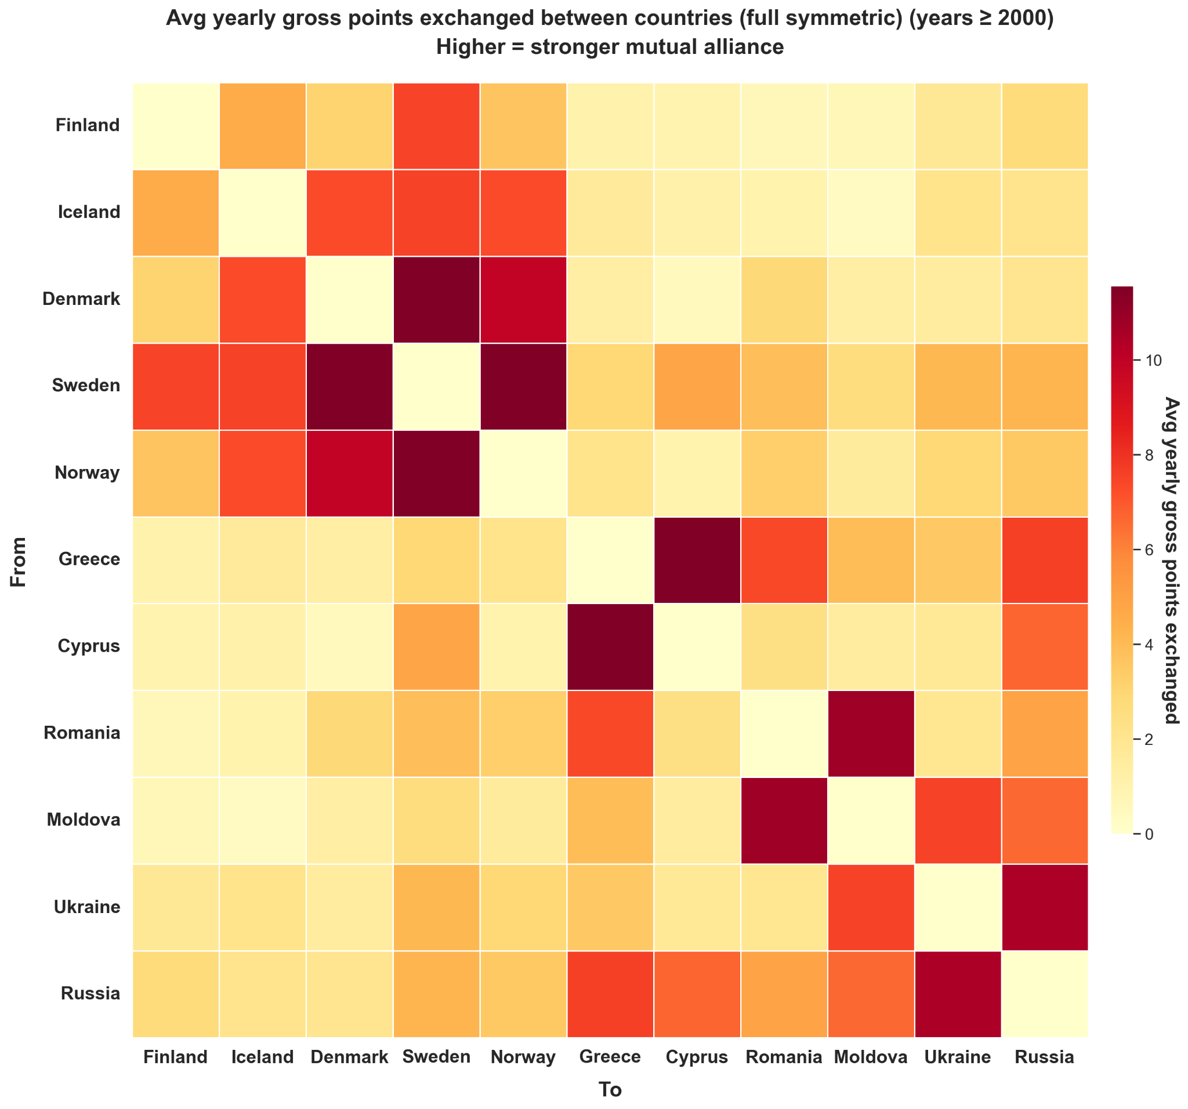
Reality Check 2: Verifying that some countries receive more points from the jury, while others receive more from the public, and that overall it is relatively balanced.
- Visualization: Each bar represents the average yearly difference between the jury points and televote points a specific country received.
- Did we see what we expected? Yes. The graph shows a balanced split between countries favored by the jury and countries favored by the public.
